Physics 30 Lesson 34 – Quantum Mechanics (optional reading)

This lesson is **not** a part of the Physics 30 curriculum. However, this lesson completes the story of our current understanding of the electron structure of the atom. In addition, this lesson may be of benefit to those who are moving on to more advanced studies in physics and chemistry.

Ernest Rutherford’s model of the atom was quite easy to visualize and understand conceptually, but, as we have seen, it had severe flaws when it was scrutinised. Neils Bohr’s quantum model of the atom was quite successful at describing the basic properties of hydrogen and it could also be easily visualized. It was successful at predicting the emission and absorption spectra for hydrogen, but it could not account for the effect of magnetic fields on the emission of light along with other observed phenomena. However, by adding several other quantum numbers to describe fine differences in energy and the effects of magnetic fields, Bohr’s model was modified to fit what had been observed. But in the end a different approach to the problem was required.

[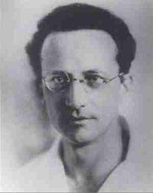](http://en.wikipedia.org/wiki/Image:Erwin_Schr%C3%B6dinger2.jpg)Two people attempted to solve the problem, but from different starting points. In 1926, Erwin Schrödinger (1887-1961) sought to express the dual wave-particle nature of matter in mathematical equations. Schrödinger assumed that de Broglie waves associated with electrons would resemble classical waves of light. Therefore, just as there is a wave equation for electromagnetic waves, there should be a **wave equation** that works for matter waves. Like Schrödinger, Werner Heisenberg tried to improve Bohr’s model of the atom. He started from the assumption that the **electron was a particle** circling the nucleus. To derive his matrix mechanics, he used data from the spectral lines produced by the various elements. The complex mathematics produced an energy equation rather than Schrödinger’s wave equation. Later it was shown that one model could be derived from the other and were therefore equivalent. Today, physicists and chemists almost exclusively use Schrödinger’s wave equation.

The resulting theory, now called **wave mechanics** or **quantum mechanics**, has been amazingly successful. Though its principles may seem strange to us whose experiences are limited to the large macroscopic world, and though the mathematics required to solve even the simplest problem is quite involved, there seems to be no alternative to correctly describe the experimental results in atomic and nuclear physics.

# The quantum model of the atom

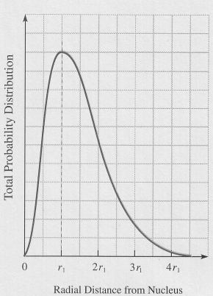Schrödinger’s wave mechanical model is almost entirely mathematical in form and function. While quantum mechanics is a highly successful **mathematical** model, it is not easily visualized as a **physical** model. Schrödinger’s model describes the electrons belonging to an atom in terms of **four quantum numbers** (see below) from which the wave function for each electron can be calculated. Instead of electrons orbiting a nucleus in an assigned place at a given time, the wave mechanical model provides a **probability** of where an electron may be found. For example, the probability distribution curve to the right is for hydrogen in its ground energy state. It indicates that while the electron is found on average at the Bohr radius (r1), its position may be further from or closer to the nucleus at any given time.

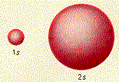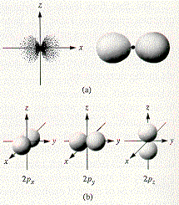For instructional purposes, it is beneficial to have a visual picture of what the electrons are doing according to Schrödinger’s wave mechanical model before discussing the quantum numbers and what they mean. While the details are discussed below, the quantum mechanical model provides us with a **probability space** for where every electron may be found around an atom. The diagrams below are sketches of the expected shapes of some of the **orbitals** and their orientations in space. Strictly speaking, the pictures are not the shapes of the orbitals; rather the pictures represent the space where an electron will be found 90% of the time. (The 100% probability is that the electron is somewhere in the universe, which is not overly helpful.) It is also important to realize that the shapes represent probability spaces that, like the rind of an orange, have a thickness to them. For example, the s orbital represents a probability space like a hollow sphere with a thick shell. An electron in the s orbital is found in the spherical shell 90% of the time. This applies to the p, d and f orbitals illustrated below as well.

The p orbitals are illustrated to the right. Illustration (a) indicates the electron probability distribution and the boundary surface for a p orbital.

The (b) illustrations show the boundary surface representations of all three p orbitals in the x, y and z orientations.

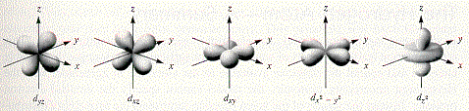

The shapes of the five d orbitals are even more interesting and exotic.

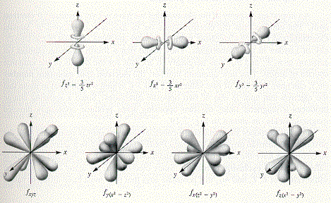

There are seven f orbitals.

# Quantum numbers

Originally, Bohr’s model of the atom required just one quantum number to describe the energy of the electron. The first quantum number (n) is called the **principle quantum number** or the Bohr quantum number, and as we saw in Lesson 31, it can have any integer value: 1, 2, 3 … ∞. It describes the**energy level** or **shell** of the electron and is closely associated with the absorption and emission spectra of atoms. But the observed behaviour of hydrogen and other atoms eventually necessitated three additional quantum numbers l, ml and ms.

The second quantum number (l) is called the **angular momentum quantum number**. It originated from the observation that individual spectral lines for hydrogen actually consisted of several lines, very close together. A very small additional energy term was required to produce the observed multiplet structure. This number indicates the types of sub-energy levels or **subshells** in which you will find the electron and its values are from 0 to n–1. For example, for the third energy level (n = 3) l can have values of 0, 1 and 2. For historical reasons, the value l is identified by a letter symbol according to the scheme

l 0 1 2 3 4 5 …

Subshell symbol *s p d f g h*

For example, the third energy level or shell consists of three subshells 3s, 3p and 3d and the fourth energy level consists of four subshells 4s, 4p, 4d and 4f.

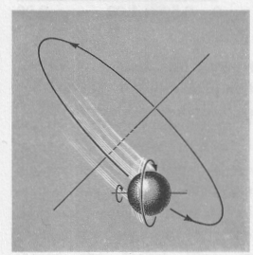

revolution

rotation

The final quantum numbers, ml and ms, are related to the magnetic properties that electrons possess by virtue of being moving charges. There are two electron motions to consider: **revolution** around the nucleus and **rotation**. (Recall from Lesson 19 that magnetic fields are generated by the motion of charges. In that lesson we also learned about the domain theory to provide an explanation of the magnetic properties of ferromagnetic substances. Now we see that, in fact, “domains” are actually the result of revolutions and rotations of electrons around atoms.)

The third quantum number (ml ) is called the **orbital magnetic quantum number**. The orbital magnetic quantum number originated as a response to the Zeeman effect. In 1896, Pieter Zeeman placed a sodium flame, with its characteristic double yellow spectral lines, within a powerful electromagnet. Whenever the current was turned on the two lines were distinctly widened. Thus, an applied magnetic field influences the way atoms emit light. In the example, the left emission spectrum is without a magnetic field, while to the right, the application of a magnetic field causes the atom to have three close together excited states. The result is three emission lines where ordinarily there is only one. For states other than the n = 1 (for which l = 0 and ml = 0), an applied magnetic field will split the energy levels into 3, 5, etc. sublevels whose separation depends on the strength of the applied magnetic field.

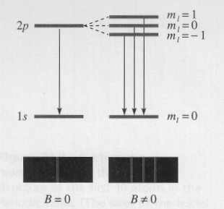

The orbital magnetic quantum number is related to the magnetic states that arise from its revolutionary motion and has values that range from – l to + l. The number signifies the **orientation** of the **orbital**. For the second subshell, for example, it designates whether the electron is in the px, py or pz orbital. For example if n = 2 then l can have values of 0 or 1.

If l = 0, ml  can only have a value of 0 and thus only one type of s orbital (2s) exists.

If l = 1 then ml  can have values of –1, 0, and +1.

–1 tells us that the electron is found in the 2px orbital.

0 tells us that the electron is found in the 2py orbital.

+1 tells us that the electron is found in the 2pz orbital.

These orbitals are of roughly equivalent energy value but correspond to three different electron spatial orientations.

The fourth quantum number (ms) is called the **spin quantum number** and, in a crude fashion, it describes the direction of rotation or **spin** (–½ or +½) of the electron in the orbital. Each orbital holds a maximum of 2 electrons, one of each spin.

# Pauli exclusion principle

To summarise, electrons move around a nucleus in specific “allowed” orbits. Each electron is characterized by four quantum numbers: n, l, ml and ms. Electron energies are (largely) determined by the primary quantum number n. The shape and orientation of the electron orbits are determined by the l and ml quantum numbers, and the spin of an electron by the ms quantum number. But at this point several problems present themselves. First, since the primary quantum number n can have any value from 1 to ∞, each electron can have an infinite number of descriptions. Second, nothing in the quantum mechanical model prevents all of the electrons around an atom from piling up in the first (n = 1) energy level.

[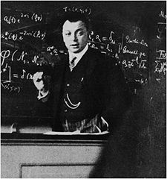](http://en.wikipedia.org/wiki/Image:Wolfgang_Pauli2.jpg)A solution to these problems was formulated in 1926 by Wolfgang Pauli (1900-1958) which would eventually earn him the Nobel prize for physics in 1945. Pauli formulated what would later be called the **Pauli Exclusion Principle**, which states:

No two electrons in the sameatom may be described by the same set of four quantum numbers.

It is this principle which keeps electrons in order. If this principle did not hold, atoms, chemistry, life would not exist.

# Electron structure

It's no simple matter to sort out electron structure. For that analysis, chemical behaviour and atomic spec­tra were required as guides. As stated above, electrons are ordered in shells and subshells about the various nuclei according to rules associated with their quantum numbers. Each shell corresponds to a specific value of n, and they are traditionally given letter names, where

Shell = K L M N O …

n = 1 2 3 4 5 …

Remember that l ranges from (n – 1) to 0; that ml goes from –l to +l; and that ms

is either –½ or +½. Again, by tradition, the states of an electron are given letter names, where

Subshell = s p d f g h …

l = 0 1 2 3 4 5 …

To summarise, a **shell** is a group of states that have the same principal quantum number. A **sub­shell** is a smaller group of states that has both the same value of n and l. An **orbital** is specified by the three quantum numbers n, l and ml, and it can contain two electrons; one spin-up, one spin-down. And a **state** is specified by all four quantum numbers and contains one electron, as per the Exclusion Principle. The table below summarises the shorthand designations of orbitals that are used to describe the electronic structure of atoms.

|  |  |  |  |
| --- | --- | --- | --- |
| Summation of orbital types and numbers | | | |
| n  (shell) | l | ml | Subshells  (from n and l) | Number of orbitals  (from number of ml values) |
| 1 | 0 | 0 | 1s | 1 |
| 2  2 | 0  1 | 0  +1,0,–1 | 2s  2p | 1  3 |
| 3  3  3 | 0  1  2 | 0  +1,0,–1  +2,+1,0,–1,–2 | 3s  3p  3d | 1  3  5 |
| 4  4  4  4 | 0  1  2  3 | 0  +1,0,–1  +2,+1,0,–1,–2  +3,+2,+1,0,–1,–2,–3 | 4s  4p  4d  4f | 1  3  5  7 |

Note that the orbitals match the probability shapes for a given subshell that we saw earlier in this lesson. When quantum numbers are calculated for all the electrons in a particular element we get a detailed picture of the possible shape of this atom. For example, the quantum numbers for the 11 electrons of an atom of sodium in their ground states is given below:

|  |  |  |  |  |
| --- | --- | --- | --- | --- |
| n | l | ml | ms | electron “location” |
| 1  1  2  2  2  2  2  2  2  2  3 | 0  0  0  0  1  1  1  1  1  1  0 | 0  0  0  0  1  1  0  0  -1  -1  0 | ½  -½  ½  -½  ½  -½  ½  -½  ½  -½  ½ |  |

The overall electron structure for sodium is written as . To visualise the electrons in this atom requires a small spherical shape near the nucleus, with a larger spherical shape along with 3 figure eight shapes in the x, y and z orientations, with a final electron in a larger spherical shape enveloping the other electron distributions.

# Electron orbital patterns and chemical periodicity

The relatively simple emission spectrum of hydrogen, and the excellent agreement of the calculated energy levels with that spectrum, are due to the electrical simplicity of this system with one electron and one proton. As soon as more than one electron is present in an atom, the observed emission spectrum of such an atom is more complex. Accordingly, as we proceed through the periodic table, we find that the com­plexity of atomic emission spectra increases as the number of electrons in the emitting atoms increases. With many electrons in an atom being excited to emit energy, there results a very intricate and difficult-to-­interpret overlapping of spectral emission lines. Moreover, theoretical considerations of many-electron atoms become greatly more complicated.

In the wave equation leading to the quantum mechanical model, there appears an electrical potential energy term. For the hydrogen atom with its one electron and one proton, that term is known. For atoms with many electrons and many protons, the potential energy term can only be approximated. Using approximations, then, in the solution of the Schrödinger wave equation for many-electron atoms, theoretical scientists have determined the best approximations of orbital patterns for such a­toms. The diagram below qualitatively shows the calculated orbital pattern for a many-electron atom based on the quantum mechanical treatment.



Maximum electron population

32

32

18

18

8

8

2

Note that we find the same pattern of the number of electrons per shell matching the number of elements in each period of the periodic table. This is one of the triumphs of modern atomic theory, the theoretical justification for the periodic classification of the elements.

# Molecular shapes – covalent bonding

Schrödinger’s wave mechanical model was also able to explain the bonding and shape characteristics of molecules. For example, water is composed of two hydrogen atoms with 1s orbitals and an oxygen atom with 1s, 2s, and 2p orbitals. When the orbitals of hydrogen and oxygen combine, a **hybrid** form emerges through the process of **hybridization**. The result is the characteristic V-shape of a water molecule.

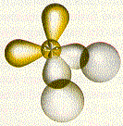

hydrogen atoms

lone pairs of

electrons

water molecule

Other examples:

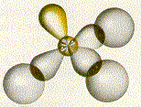 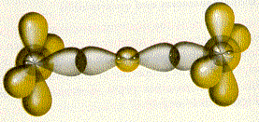

beryllium fluoride (BeF2)

ammonia (NH3)

You will learn far more about chemical bonding in future studies.